
Proposal Cover Sheet
Subject Code: |  | CSIT321
Subject Name: |  | Project
Submission Type: |  | Project Proposal
Project Title: |  | InnovaCX
Team Name: |  | InnovaAI
Student Name: |  | Hana Ayad, Yara Saab, Leen Naser, Majid Sharaf, Ali AlMaharif, Rami Alassi, Hamad Subhi
Student Number: |  | 8274484, 8255593, 8198731, 8104104, 8526898, 8456434, 8489920
Student Phone Number: |  | 0551202309, 0585585302, 0504994703, 0554706706, 0569709990, 0502368071, 0544587004
Student E-mail: |  | Haa210@uowmail.edu.edu, yefs367@uowmail.edu.au, lmfn660@uowmail.edu.au, mmsas879@uowmail.edu.au, aoam872@uowmail.edu.au, rtsa882@uowmail.edu.au, has071@uowmail.edu.au
Lecturer Name: |  | Dr. Nkqubela Ruxwana
Due Date: |  | 28-10-2025
Date Submitted: |  | 28-10-2025
 | PLAGIARISM:  The penalty for deliberate plagiarism is FAILURE in the subject. Plagiarism is cheating by using the written ideas or submitted work of someone else. UOWD has a strong policy against plagiarism.  The University of Wollongong in Dubai also endorses a policy of non-discriminatory language practice and presentation.  PLEASE NOTE: STUDENTS MUST RETAIN A COPY OF ANY WORK SUBMITTED |  | DECLARATION:  I/We certify that this is entirely my/our own work, except where I/we have given fully-documented references to the work of others, and that the material contained in this document has not previously been submitted for assessment in any formal course of study. I/we understand the definition and consequences of plagiarism.  Signature of Student: Hana Ayad - Yara Saab – Leen Naser - Majid Sharaf - Ali AlMaharif - Rami Alassi - Hamad Subhi
Optional Marks:
Comments:

Lecturer Project Proposal Receipt (To be filled in by student and retained by Lecturer upon return of assignment)
Subject: CSIT321 | Project Title: InnovaCX
Student Name: Hana Ayad, Yara Saab, Leen Naser, Majid Sharaf, Ali AlMaharif, Rami Alassi, Hamad Subhi | Student Number: 8274484, 8255593, 8198731, 8104104, 8526898, 8456434, 8489920
Due Date: 28-10-2025 | Date Submitted: 28-10-2025
Signature of Student: Hana Ayad, Yara Saab, Leen Naser, Majid Sharaf, Ali AlMaharif, Rami Alassi, Hamad Subhi

Student Project Proposal Receipt (To be filled in and retained by Student upon submission of assignment)
Subject: CSIT321 | Project Title: InnovaCX
Student Name: Hana Ayad, Yara Saab, Leen Naser, Majid Sharaf, Ali AlMaharif, Rami Alassi, Hamad Subhi | Student Number: 8274484, 8255593, 8198731, 8104104, 8526898, 8456434, 8489920
Due Date: 28-10-2025 | Date Submitted: 28-10-2025
Signature of Lecturer

InnovaAI
CSIT321 – Project

Table of Contents
Background Information 5
Project Description and Objectives 5
What is our Project? 5
Main problems and how we address them? 6
Project Scope 7
Competitor Solutions and Their Limitations 8
Target Niche 9
Economic Feasibility 10
Organizational Feasibility 10
Pre-requisites 11
Technical Prerequisites 11
Data Prerequisites 11
Organizational Access Prerequisites 12
Knowledge Prerequisites 12
Limitations 12
How Will We Do It? 13
System Overview 13
Core Features 13
Chatbot 13
Formal Complaint Screen 14
Historical Data and Model Training 14
Sentimental Analysis and Prioritization Model 14
Employee Escalation Screen 14
Results Dashboard 14
High-Level System Architecture 15
State Diagram 16
Component Diagram 17
Deployment Diagram 17
The High-Level System Operation 19
Software and Hardware Requirements 20
Software Requirements 20
Hardware Requirements 21
Challenges 22
Risk Mitigation 23
Future Improvements 24
Timeline 26
Gantt Charts 26
Project Management Tools to be Used 27
Teamwork Distribution 27
Member 1 – Integration and Version Control Lead (Leen Naser) 27
Member 2 – Database Architect ( 27
Member 3 – Frontend Developer ( 28
Member 4 – Backend Developer (Rami Alassi) 28
Member 5 – AI Developer (Text) ( 28
Member 6 – AI Developer (Audio) ( 28
Member 7 – Chatbot Engineer ( 28
References 29

Background Information
Dubai CommerCity is one of Dubai’s leading free zones, and it is dedicated to supporting the world of digital commerce. The organization manages a large number of inquiries and complaints from tenants, partners, and customers every day, as part of its customer experience framework. These messages come in many ways including online portals, emails, and call centers, and usually they come long, unstructured, and in different tones. The huge number of complaints and the lack of an effective system for prioritization makes the time it takes to resolve issues longer, as well as that some are unintentionally delayed or overlooked as new ones come in. Typically, it takes around 2–7 business days for a complaint to be processed and resolved, but with our system, this duration is expected to be significantly reduced. Over time, this inefficiency harms customer satisfaction, damages brand reputation, and affects customer loyalty, especially in a competitive market like Dubai’s digital commerce sector.
This project aims to improve the way complaints are managed through the use of artificial intelligence. Although many organizations already rely on ticketing and CRM systems, very few integrate emotion or sentimental analysis to understand how urgent or severe a customer’s concern really is. Emotional intelligence is important because without it a frustrated customer’s issue might be treated with the same level of importance as a simple inquiry, leading to delays and dissatisfaction. By integrating this AI-based approach and automated prioritization, organizations can detect which complaints require immediate attention, and which ones can be handled through automated responses or self-service options.
InnovaCX is designed to bring this intelligence into action. Created in collaboration with Dubai CommerCity, the system is not meant to replace existing tools but to enhance them by adding advanced analytics, emotional awareness, and intelligent prioritization to the current customer service process. The project supports Dubai’s ongoing vision for digital transformation and service excellence, offering a scalable model that can later be adopted by other organizations facing similar challenges in managing high volumes of customer complaints.

Project Description and Objectives

What is our Project?
InnovaCX is an AI-powered sentimental analysis model for customer support and complaint management and prioritization, that uses natural language processing (NLP) and audio-based emotion recognition to analyze and classify customer complaints. The system processes both text and audio-based messages, and it converts audio inputs into text through an integrated speech-to-text module, while also saving the audio as a recording. After that, it applies sentiment analysis to identify the emotional tone and urgency of each complaint. The system then automatically sends the complaint to the right department, making sure that urgent issues receive immediate attention while simple ones are handled efficiently through the chatbot.
The model also reviews logged complaint data and customer profiles to ensure the prioritization is accurate. It combines several factors like emotion through the tone, the topic of the complaint, and customer value, to generate an overall priority score that helps organizations respond quickly to critical issues. In addition to that, a user-friendly management dashboard will be provided that shows real-time analytics such as complaint counts, average resolution times, high-priority cases, and chatbot performance. This helps operational teams see a clear view of issues and thus stay on track.
The goal of the project is to make responses more time-efficient, reduce manual effort, and enhance the overall customer experience. It introduces a smart, hybrid model where low-severity complaints are managed automatically by a chatbot, while high-priority ones are escalated to human agents based on the priority score and assigned department.

Main problems and how they are addressed
Dubai CommerCity and other large organizations currently face a major challenge in efficiently organizing and prioritizing customer complaints. The huge number of unstructured complaints leads to significant delays and inconsistencies in responses. It has been observed one multiple occassions that an urgent complaint such as system failure was delayed and treated in the manner a general inquiry would be, which leads to customer dissatisfaction or potentially damage.
InnovaCX directly addresses this issue by introducing emotional and contextual intelligence into the complaint management workflow. The system uses advanced NLP models such as RoBERTa and pysentimiento to analyze the sentiment and severity of text-based complaints and uses the librosa library to process audio logs and extract features like the pitch and tempo to get the emotional intensity of the complaint. This approach ensures that both the content and tone are taken into consideration before prioritizing a message.
After analyzing, the system checks all the factors and decides a category for the complaint based on its topic. This way the complaint is routed automatically to the relevant department, such as maintenance or finance, ensuring it is resolved faster. The system will account for how valuable a customer is. How this works is that high-value customers or repeated complaint submitters are automatically assigned to a higher priority level.
At the end, a ranked complaint list will be available to management to view in real time, through an interactive dashboard that shows key performance indicators such as average time to resolve a complaint, percentage of complaints handled by the chatbot, and level of customer satisfaction.
InnovaCX bridges the gap between existing CRM systems and the need for emotional intelligence in customer experience management. It empowers organizations to make data-driven decisions, reduce operational bottlenecks, and retain customer trust by responding both logically and emotionally.

Project Scope
The scope of InnovaCX is to create, develop, and assess an AI-powered sentiment analysis system that can intelligently process, analyze, and prioritize customer complaints that are provided through text and audio channels. By identifying the emotional tone, urgency, and overall significance of each complaint, the system seeks to optimize the complaint management system, enabling companies and organizations to respond more effectively to their clients.
The project covers the full complaint management lifecycle, from complaint intake to resolution tracking. After the system receives a complaint, it determines whether human intervention is necessary or if it can be handled automatically by the chatbot. The chatbot is responsible for handling simple or recurrent issues, such as basic inquiries or frequently asked questions, while more complex or emotionally charged complaints are escalated to human agents. Throughout this process, InnovaCX regularly monitors and reports the bot’s performance, showing the percentage of total complaints that are resolved automatically and the extent to which human intervention remains necessary. For example, the system will be able to identify that out of 200 incoming complaints, the chatbot successfully handled 140 cases, while the remaining 60 were escalated for manual review.
A prioritization model will then combine sentiment, severity, and customer value to assign a dynamic priority score that establishes the sequence in which complaints should be addressed. To determine the importance of a complaint, the priority engine combines a number of factors, such as sentiment score, emotional intensity, the type of issue, and the customer's value or complaint history. Routine or low-priority cases are sent to the chatbot layer for automated assistance, while high-priority cases are automatically routed to the relevant department, guaranteeing that urgent issues are resolved as quickly as possible.
A key feature of InnovaCX is the interactive management dashboard, which offers real-time insights into system performance and operational responsiveness. The dashboard will show the total number of complaints received, how many of those were successfully resolved, and how many were classified as high priority. Additionally, it keeps track of each complaint's overall time to closure, allowing managers to keep an eye on the average resolution times and identify workflow bottlenecks. For evaluation, key performance indicators (KPIs) such as response time, resolution efficiency, and the ratio of automated to manual resolutions will be clearly visualized.
The dashboard will also include a recommender module that suggests how each complaint should be addressed or resolved based on previous resolution patterns and categorized complaint types. For instance, if there's a complaint related to air conditioning, the system will automatically recommend directing it to the maintenance department, and may even recommend the next course of action. These features ensure that common or recurring problems are resolved quickly across departments.
Furthermore, a topic-wise categorization and sentiment tracking layer is going to be implemented. This layer offers two levels of insight. First, it identifies the topics that customers complain about most frequently, and second, it analyzes the emotional sentiment within each topic to determine which areas cause the highest levels of dissatisfaction or frustration. Together, these insights help management in making well-informed decisions regarding raising customer service standards and operating procedures.
Although the system's pilot organization is Dubai CommerCity, InnovaCX is made to be scalable and easily modified for implementation in other industries that handle high volumes of customer complaints.

Competitor Solutions and Their Limitations
Several platforms in today's market provide tools for automating customer service and complaint management, yet very few incorporate emotion detection or prioritization based on customer sentiment. Among the most established and recognized solutions is Salesforce Service Cloud, a customer relationship management (CRM) platform, providing ticket tracking, workflow automation, and analytics (Carpio-Talleux, 2025). However, it depends heavily on manual categorization and rule-based logic. It does not analyze emotion or urgency from customer messages, which means that emotionally critical issues may not be prioritized or would get overridden and lost.
IBM Watson Assistant represents another notable competitor that utilizes artificial intelligence and natural language processing (NLP) for chatbot automation and sentiment detection within text-based complaints. While effective for basic automation, its analysis remains limited to textual cues and does not integrate voice-based sentiment or real-time prioritization (Kemp, 2021). It also lacks a prioritization engine that evaluates how urgent or severe a complaint is, nor does it provide insight into how the chatbot’s responses perform over time. As a result, while Watson excels at automating interactions, it is less effective in managing the emotional context that influences customer satisfaction.
Other well-known platforms such as Freshdesk and Zendesk, offer efficient customer service automation and ticketing systems. They are effective for tracking resolution progress and managing large numbers of complaints they do not analyze the emotional state of the customer, nor prioritize responses (Panah, 2025). Similarly, emerging tools like Cogito and CallMiner provide voice analytics to assess tone and sentiment in live calls. However, they are designed primarily toward call centers and lack integration with text-based complaints or CRM systems (James, 2025). They also require subscriptions and are costly to implement, limiting their scalability and making them less suitable for organization-wide deployment or smaller enterprises.
InnovaCX fills these gaps by combining both text and audio emotion analysis with a dynamic prioritization model that accounts for sentiment, severity, and customer value. It not only categorizes complaints and determines urgency, but also features a dashboard that visualizes complaint flow, resolution metrics, and system performance. This dual focus on emotional intelligence and performance, as well as the integration of both text and audio analysis, gives InnovaCX a unique competitive advantage over existing market solutions.

Target Niche
Although InnovaCX is being developed in collaboration with Dubai CommerCity, it is designed as a general-purpose and scalable solution that can be implemented or adopted by any organization that receives a high volume of customer complaints and inquiries. Its adaptability makes it suitable for companies in sectors such as e-commerce, logistics, government agencies, and delivery companies that deal with both text-based and verbal communication from their customers, and all of which rely heavily on customer satisfaction and timely complaint resolution.
The system is especially valuable for organizations that already use a CRM or ticketing system but lack advanced prioritization or emotional intelligence features. Instead of replacing existing infrastructure, InnovaCX acts as an enhancement layer that improves its efficiency by adding a smart analytical layer capable of understanding sentiment, ranking urgency, and recommending solutions. Unlike many systems that are rigidly tied to a specific company's infrastructure, InnovaCX is flexible, allowing it to work alongside existing CRMs or helpdesk platforms. This makes it ideal for those seeking to optimize and enhance their existing workflows rather than undertake costly replacements of their full system.
InnovaCX's adaptability means that it can support small and medium-sized enterprises that handle customer inquiries through emails or web forms, as well as large corporations managing thousands of calls per day. For Dubai CommerCity, InnovaCX will act as a pilot implementation that demonstrates how AI can transform complaint management into a more efficient, empathetic, and data-driven process that can later be replicated in other organizations. These features aim to improve customer retention and brand reputation, not only for DCC but it can serve as a potential reference model for how AI-powered sentiment analysis and prioritization can enhance customer relationships across diverse sectors in the UAE and beyond.

Economic Feasibility
The development of InnovaCX is financially feasible as it will be developed and deployed using AWS services and basing it off a rough estimation using AWS cost estimators, for a pilot demonstration the relative costs were calculated to be in the range between $180 - $200. Depending on differing use cases and larger data sets, the costs will increase, although remains in the range of being deemed financially feasible and a worthwhile investment.
The project management platform Notion will be utilized under its free academic plan. All APIs and essential development tools used are open source and free. In order to guarantee smooth progress, DCC has agreed to offer us limited supplementary funding in the event that additional costs exceed the credits allotted.
Overall, the project can be completed without incurring any personal expenses, making it sustainable and economically feasible within the allocated budget.

Organizational Feasibility
The development of InnovaCX is organizationally feasible, as all required resources and infrastructure are already in place within Dubai CommerCity. The organization has provided access to the necessary dataset, ensuring full support throughout development. The data will comply with confidentiality and privacy standards, and the team will follow all required handling procedures.
The project team consists of computer science students with the technical background needed to manage development and integration effectively. Each member has a clearly defined role based on their individual strengths. Dubai CommerCity’s IT department will also provide limited technical support and supervision. With this structure and support, the project is well-positioned for successful completion.

Pre-requisites
Before the process of building the complaint management system begins, multiple requirements must be met to ensure smooth development. These prerequisites outline technical, organizational, and knowledge areas that the foundation of the project relies on. Meeting these prerequisites will mitigate risks and ease integration.

Technical Prerequisites
The first step is setting up the core technical environment and access configurations. This includes the backend and frontend structure, along with a secure cloud environment to host all main components such as the chatbot, transcription service, sentiment analysis model, and centralized database. The system should be scalable and easily adaptable to future integrations or data sources.
All API keys and authentication credentials must be obtained and secured to allow smooth communication between modules. A Git environment must also be set up for version control and source management, ensuring the team works on the same codebase, maintains consistency, and can easily trace or roll back changes when needed.

Data Prerequisites
A large, clean, and ready-to-use dataset is required for developing the complaint management system. Dubai CommerCity will provide a database of previous customer complaints and inquiries to train the sentiment analysis model. All phone logs have been transcribed, and text-based complaints have been scrubbed of sensitive details, giving the team prepared data to build on.
Personally identifiable information such as names, phone numbers, and email addresses must remain removed to maintain confidentiality and comply with data protection standards. The data must be securely stored and accessed under company confidentiality agreements. The dataset should also be diverse, covering different customer types and complaint categories, to help the model recognize emotion, urgency, and tone more accurately.

Organizational Access Prerequisites
Formal approval from Dubai CommerCity must be granted to allow the use of internal complaint data for training the sentiment analysis model, with confidentiality agreements in place to protect all information. The team must also have secure access to the database and cloud environments provided by the organization. Roles and responsibilities should be clearly defined to maintain accountability and ensure proper handling of data and system resources throughout development.

Knowledge Prerequisites
Members of the team are required to have a basic understanding of several key concepts, including building machine learning models, managing databases, performing data preprocessing, and evaluating model performance. They should also be familiar with handling large-scale projects and working collaboratively in a shared development environment to ensure smooth coordination and efficient progress throughout the project.

Limitations
Even though InnovaCX demonstrates strong potential to improve complaint management and customer satisfaction at Dubai CommerCity, some limitations may arise that could affect its overall performance.
Firstly, access to training data sets for machine learning might be limited because usually complaint data is considered highly confidential information and is only shared with authorized individuals. Using synthetic data to train the AI model will not fully reflect how real customers express their emotions or frustrations, so the emotional patterns it learns for sentiment detection could be less reliable.
Secondly, audio-based emotion recognition is used to detect the emotional intensity of a customer. However, there might be some inaccuracy in detection due to the diverse backgrounds of customers in terms of their accents, tone of voice (high or low pitch), or even background noise.
Thirdly, integrating InnovaCX with Dubai CommerCity’s proprietary APIs, such as customer database and CRMs, might be challenging due to the privacy and restricted access of some company systems. In addition, data format incompatibility issues might arise because data can be stored in different formats across platforms, for example, Excel or JSON, which makes it difficult for systems to communicate, share, or read data consistently. Finally, limited access permissions or security clearance may prevent the team from accessing certain customer complaint information, which could block full integration of InnovaCX.
Since the first semester focuses on planning, design, and documentation, the actual implementation of InnovaCX will take place next semester. Therefore, all these project limitations are based on predicted challenges and theoretical constraints rather than the performance of InnovaCX itself. Factors such as data availability, integration feasibility, and how the system can handle more users in the future will all be addressed in the development phase.

How Will We Do It?

System Overview
After the welcome screen, the system begins with a chatbot that serves as the first point of interaction for customers. If the chatbot is unable to solve the customer’s problem, the user is redirected to a formal complaint form where they can submit their issue either as text or as an audio log.
When an audio file is submitted, it is processed through an API that transcribes the speech into text while also passing the raw audio to the sentiment model for direct tone and emotion analysis. Both text and audio inputs are scrubbed for anonymity and consistency before being sent for processing.
The sentiment analysis model then evaluates the complaint using both textual and audio cues, classifying each case based on emotional tone, urgency, and complexity. The model assigns the complaint to the department best suited to handle it, along with an urgency score. All model outputs and performance metrics are stored in a database that powers a live dashboard for monitoring complaint resolution and model accuracy.

Core Features

Chatbot
The chatbot is the customer’s first point of interaction with the system, functioning like a virtual receptionist or information desk. It manages simple inquiries that would typically take days to process, resolving them within minutes when possible. However, it is not designed to handle complex or specialized issues that require expert intervention.

Formal Complaint Screen
When the chatbot is unable to resolve an issue, or if the user prefers direct submission, they can file a formal complaint through the dedicated form. The form accepts both text and audio inputs, giving users flexibility in how they express their concerns. Audio logs are automatically transcribed into text while preserving tone and emotional context, allowing the system to process both input types uniformly through the sentiment model. Before being passed to the model, all data is scrubbed for anonymity and standardized to ensure consistency and privacy.

Historical Data and Model Training
The sentiment and prioritization model is trained on previous customer calls and complaints provided in a pre-scrubbed, transcribed, and anonymized format. This enables the model to learn from real customer interactions and adapt to natural communication patterns. Training on genuine data also helps ensure fairness and reduce bias when the model is deployed in a live environment.

Sentimental Analysis and Prioritization Model
The model evaluates customer complaints using a dual-input approach, analyzing both text and audio data. For text-based complaints, it detects emotional tone, language intensity, and urgency. For audio inputs, it processes the speech waveform directly to capture vocal stress, pitch, and tone variation.
These two analyses are combined to produce a unified sentiment and urgency score, ensuring more accurate prioritization. The model then routes the complaint to the appropriate department based on category and urgency level, continuously improving through feedback collected after each resolution.

Employee Escalation Screen
Complaints are gathered here for employee review and organized by department and urgency. Employees can use this screen to respond to and resolve issues or update the status of each complaint ticket, ensuring timely handling of critical cases.

Results Dashboard
All complaint tickets are tracked through the results dashboard. When a ticket is closed or resolved, the model’s accuracy is evaluated based on employee feedback regarding the true urgency of the issue. This feedback is fed back into the system to improve future model performance. The dashboard also tracks key metrics such as resolution time, allowing the organization to monitor efficiency and identify areas for improvement.

High-Level System Architecture
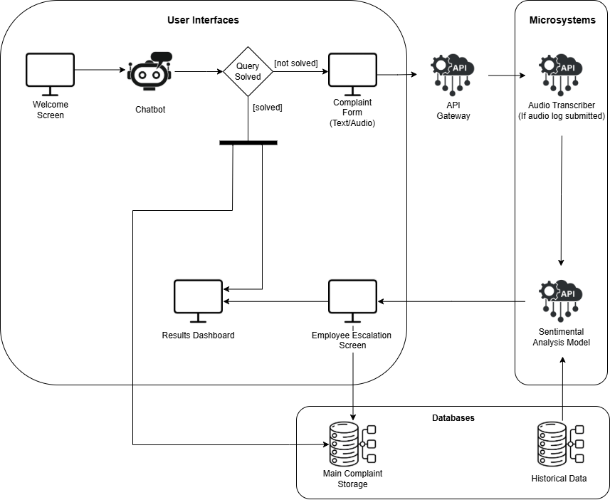

State Diagram
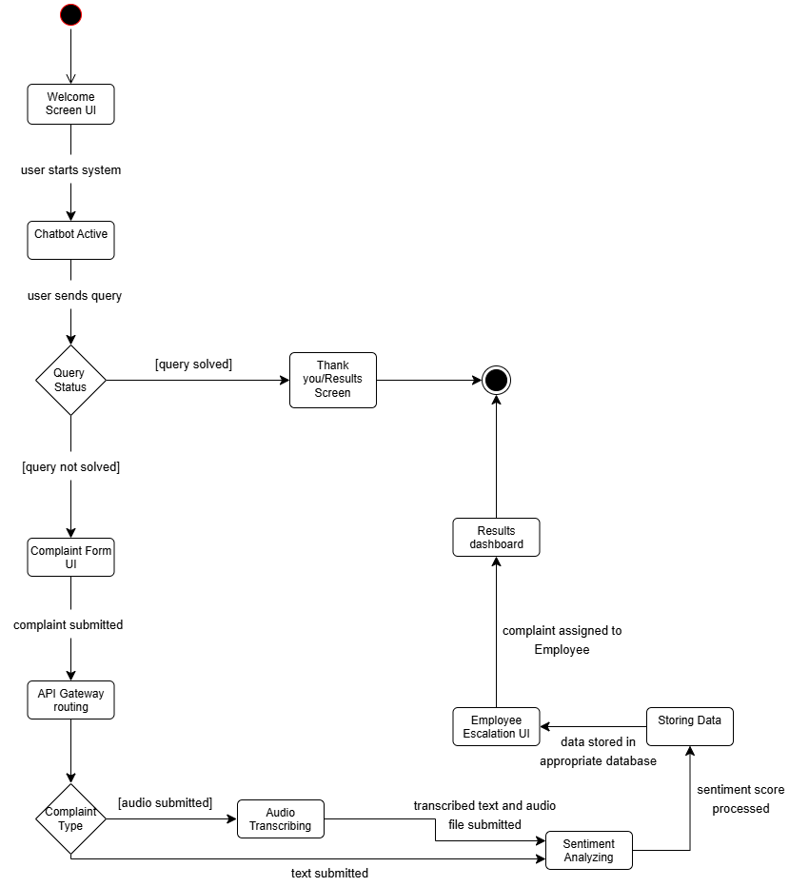

Component Diagram
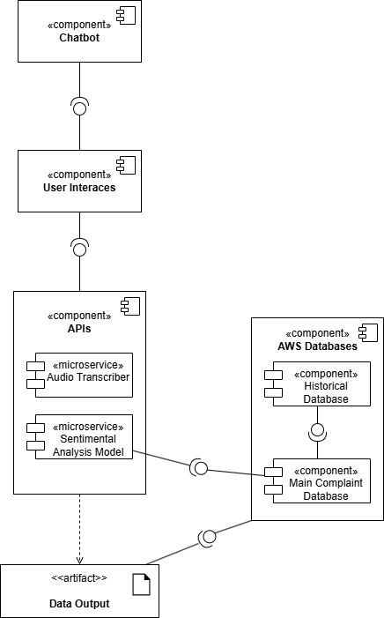

Deployment Diagram
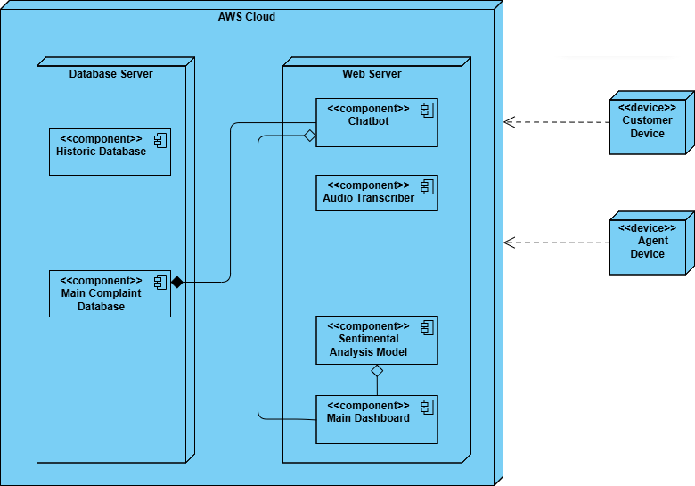

The High-Level System Operation
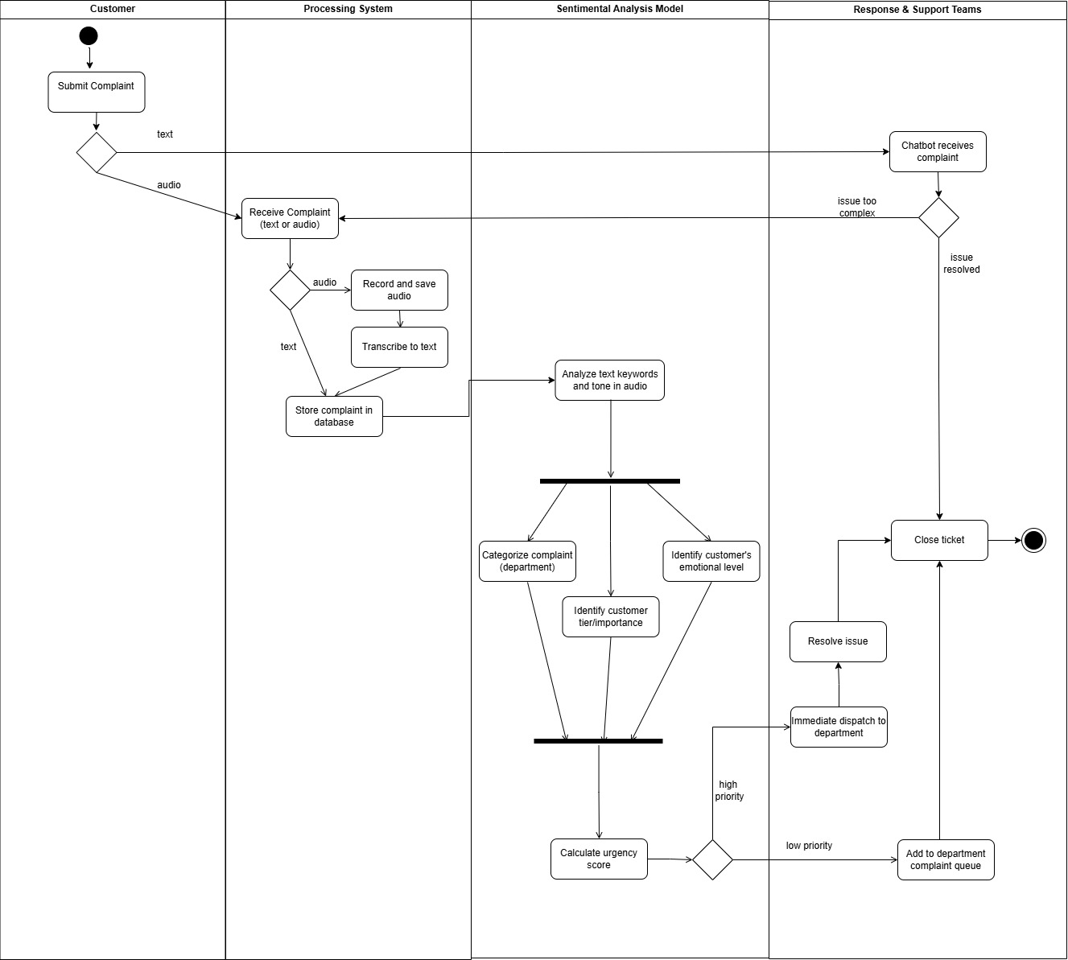

Software and Hardware Requirements

Software Requirements
Software Used:
- FastAPI
- RoBERTa
- Pysentimiento
- Whisper (speech to text transcriber)
- py-webrtcvad
- Librosa
- Rasa (Chatbot)
- PostgreSQL (Amazon RDS)
- Amazon OpenSearch Service
- Amazon S3
- MLflow
- Airflow
- Docker
- GitHub
The system is developed using a set of software tools that each play a role in processing complaints and determining their priority. FastAPI serves as the entry point of the application where complaints are submitted and managed. It coordinates how data flows across the system, ensuring that each complaint is processed consistently and that the final priority score is generated and returned.
Sentiment and emotional tone analysis is performed using RoBERTa, with pysentimiento added to classify different emotional states such as frustration, anger, urgency, or neutrality. The model will also be fine-tuned with the dataset provided, allowing it to better understand how customers within the organization express dissatisfaction. This ensures that the system develops a more relevant understanding of emotional cues rather than relying only on generic training data.
For complaints that come with audio recordings, the system includes a dedicated audio processing pipeline. The audio is first transcribed into text using Whisper, allowing call based complaints to be analyzed with the same sentiment models used for written complaints. Before transcription, py-webrtcvad is used to identify speech segments and remove silence or background noise, ensuring that Whisper processes only meaningful spoken content. After transcription, Librosa is used to extract vocal features such as pitch changes, stress patterns, and vocal intensity, which provide insight into emotional urgency that may not be fully captured in text alone. While audio is not expected to make up most of the dataset, having this ability ensures the system can handle both written and spoken communication effectively.
A chatbot layer is also included to handle minor or repetitive complaints at the initial stage. This is implemented using Rasa, which allows the system to recognize common complaint types and respond with predefined solutions when appropriate. If the chatbot detects emotional escalation, unclear intent, or issues beyond its predefined resolution patterns, it automatically escalates the complaint to the sentiment analysis and scoring pipeline. This prevents support staff from being burdened with trivial requests and ensures faster resolution for simple cases.
The priority scoring takes place directly in the FastAPI layer. Once sentiment scores (and audio emotion indicators when applicable) are generated, FastAPI merges these into a unified priority value, which determines whether a complaint should be handled immediately or can be placed into normal response workflow. The system also records both the submission and resolution timestamps, allowing the organization to monitor how long complaints take to be completed, which supports performance evaluation and operational analysis.
Complaint records, emotional scores, timestamps, and priority outcomes are stored in PostgreSQL using Amazon RDS. Processed complaint text and emotional scoring data are indexed in Amazon OpenSearch Service, enabling quick filtering, analysis, and search. Any raw logs or audio files are stored in Amazon S3, ensuring scalable and durable storage. MLflow is used to track model versions and fine-tuning progress, while Airflow manages scheduled processes such as retraining or periodic reporting tasks. The entire system is containerized using Docker, ensuring consistent deployment across environments. GitHub is used for version control and collaboration, ensuring that updates to the system are tracked, documented, and reviewed properly.

Hardware Requirements
AWS Services Used
- Amazon EC2
- Amazon RDS (PostgreSQL)
- Amazon OpenSearch Service
- Amazon S3
- (Optional) EC2 GPU instance for batch audio analysis
- CloudWatch (for monitoring & metrics)
Local hardware demands are minimal since all computation and storage are hosted in AWS. A standard development machine with an 8-core CPU, 16GB RAM, and SSD storage is sufficient for coding, local testing, container work, and committing changes to GitHub.
The deployed system runs entirely on cloud infrastructure. The main application layer, including FastAPI and the sentiment analysis model, will be hosted on an Amazon EC2 instance, typically sized as t3.medium or t3.large, which provides enough CPU performance for real-time analysis without requiring GPU acceleration. Complaint records and priority scoring history will be stored in Amazon RDS for PostgreSQL, which provides automated backup and fault tolerant database management. Amazon OpenSearch Service will be used to index processed complaint text, allowing the organization to quickly search and filter complaints based on emotional severity or keyword patterns. Amazon S3 stores raw logs and audio files and scales automatically as data volume grows.
If large batches of audio require processing, a temporary GPU enabled EC2 instance such as g5.xlarge can be used; however, because audio does not represent the majority of complaints, this remains an optional resource and is only activated when needed. CloudWatch will be used to monitor usage, performance, and operational behavior of the system over time, ensuring maintainability and early detection of issues.

Challenges
To develop InnovaCX, our team must address several technical and operational challenges throughout the project lifecycle.
One of the major challenges that will be faced is processing and analyzing multimodal data. This means that InnovaCX needs to deal with both text messages (such as chat messages) and audio data (like recorded voice complaints from calls). These types of data vary a lot in nature, so audio must be converted into text and emotional signals to be used as datasets for AI analysis. Therefore, the team must focus on preprocessing the data by organizing it, then synchronizing which audio and text belong to the same complaint and coordinating the models so that the system can accurately judge sentiment in both audio and text formats.
Another challenge is accurately analyzing sentiment and emotion because the customers are very multicultural. Dubai has a diverse population, so people may speak different languages (Arabic, English, Hindi, etc). Not only languages, but English accents can differ as well due to various home-country dialects. Emotions can be expressed differently based on people's upbringing and cultural background; for example, some people can sound polite even when upset. Therefore, AI models (like BERT or RoBERTa) need to be trained carefully, considering all these language and emotion factors, to ensure reliable analysis. Under all those factors related to language and emotion.
Moreover, data security and privacy are other important challenges that must be focused on. This is because all the information that will be obtained from customers will contain their names, contact details, complaints, and voice recordings, all of which must be kept confidential and accessible only to authorized users. The data should only be used for project purposes and handled according to UAE digital regulations and Dubai CommerCity’s privacy rules.
System integration and testing will also be challenging, as InnovaCX is made up of many modules that must cohesively work together with low coupling. For example, the transcriber oversees converting voice recordings into text, the sentiment analyzer determines customer emotion, the prioritization engine categorizes complaints based on urgency, and the user dashboard presents all this information to the employees. The team will have to split the tasks to build those tools, and potentially use different programming languages or interfaces, so the difficult part will be integrating everything smoothly. For example, the transcriber’s output must be understood by the sentiment analyzer, correctly categorized in the priority queue, and accurately presented in the dashboard. Testing then becomes a challenge because if one part does not work, the entire system might not function properly. Each team member must implement unit testing in every module and then perform integration testing on the entire system to avoid problems with functionality.
Finally, staying organized as a group and keeping everyone's work up to date can also be challenging. As a team of seven, we must address project coordination and version control challenges to ensure progress is consistent across data, coding, and design components.

Risk Mitigation
Every project faces risks that could impact the results or delay progress. Our team has identified several risks that may arise during the development of InnovaCX and how they will be mitigated.
- Project Timeline and Task Overload
There is a risk of falling behind schedule if some tasks take longer than expected due to technical issues or uneven distribution of work among group members. To mitigate this, clear weekly goals will be set, tasks will be distributed evenly by assigning members to areas they are skilled in, and progress will be reviewed weekly to identify and resolve any issues earlier rather than at the last minute.

- Technical Uncertainty
When it comes to APIs and AI models, some tools might not produce the expected results or may face compatibility issues and software bugs, leading to a poor connection between modules. To mitigate this risk, we will have backup tools and alternative solutions (Plan B) ready to perform early testing and fix issues during the early development stages before integration and deployment phases. Additionally, because the system combines multiple modules, modular development and version control through GitHub will be used to maintain consistency and ensure smooth integration.
- Knowledge Gaps
Some complex tasks, such as NLP training and backend development, require advanced technical knowledge. To manage this risk, tasks will be distributed based on each member’s strengths while maintaining fairness. The team will focus on self-learning and regularly update the supervisor about any challenges or technical difficulties faced during development.
- Communication Breakdowns
As a group of seven members, miscommunication may occur, which may lead to duplicated work or unclear task outcomes. To mitigate this, Notion will be used to keep all members informed about specific responsibilities through clear documentation and task tracking. Regular discussions will also help ensure that everyone stays aligned.
- Resource and Tool Dependency
If a specific resource, such as dataset sources, GitHub, or Notion, becomes unavailable, progress can be affected and work may be lost, causing delays. To reduce this risk, the team will keep local backups of all important files, prepare backup datasets, and have alternative tools or platforms to avoid major disruptions.

Future Improvements
As our customer support system (InnovaCX) continues to evolve, several future improvements can be implemented to increase its efficiency, intelligence and overall customer satisfaction. The following improvements aim to automate operations further and strengthen customer satisfaction through the utilization of advanced and innovative technologies. While the ideas are promising, we aren’t implementing them in the current phase due to resource and time constraints.
One major improvement that can be implemented is the integration of an AI-powered voice virtual assistant that would be able to answer customer calls and provide real-time feedback. The virtual assistant would operate very similarly to how a human employee would and would escalate complex cases to the relevant department. Implementing this would significantly reduce response times via calls and improve the customer’s experience while maintaining a professional and empathetic communication style. However, implementing this feature would require advanced speech recognition, and voice synthesis models, which are complex and costly. Given our 6-month timeline, and limited budget, this addition will be postponed to a future phase.
Another potential enhancement is introducing robotics for on-site diagnosis and maintenance scheduling. These robots could be deployed to investigate the reported issues, analyze conditions at the customer’s sites, and automatically provide feedback to the central system. Based on this information, they will be able to place maintenance requests and coordinate schedules with the relevant teams, which helps streamline the operational efficiency and minimize human error. Although this would improve operational efficiency, the costs and infrastructure required for robotics are beyond the projects' current scope, making implementation unfeasible within the current timeframe and resources.
Additionally, developing an API capable of calculating query complexity would help categorize and prioritize customer complaints based on their level of difficulty. This would enable the system to redirect complex cases to experienced agents while handling simpler queries automatically, which would optimize resource allocation within the support team. While this is technically feasible, building and training this API requires sufficient historical data and development time, which exceeds what can be achieved during this development cycle.
To better serve Dubai’s multicultural environment, implementing multilingual sentiment analysis would be a valuable improvement. As it would enable the system to detect and interpret emotions in multiple languages such as Arabic, Russian, Hindi. While this would significantly improve the inclusivity within the community. The development and validation required to ensure an accurate model for multiple languages requires significant time and resources, which are beyond the capacity of our current team and budget.
Lastly, we could develop a predictive customer satisfaction scoring model that would be trained on historical sentiment and complaints data which will then allow the system to identify potential dissatisfaction trends early on, alert support teams before issues escalate and enable timely intervention to maintain high levels of customer satisfaction. Since this enhancement depends on significant data and testing, it cannot be realistically achieved within the present development period.
In conclusion, these future improvements represent the next stage in the evolution of InnovaCX transforming our system from a responsive customer support system into an intelligent, proactive, and fully integrated service platform capable of independently addressing and resolving customer queries and complaints through advanced technologies. Given the current limitations in time, budget, and resources it prevents us from immediately implementing these improvements, each of these innovations lay out the groundwork for a smarter, more efficient, and customer-centric future.

Timeline

Gantt Charts
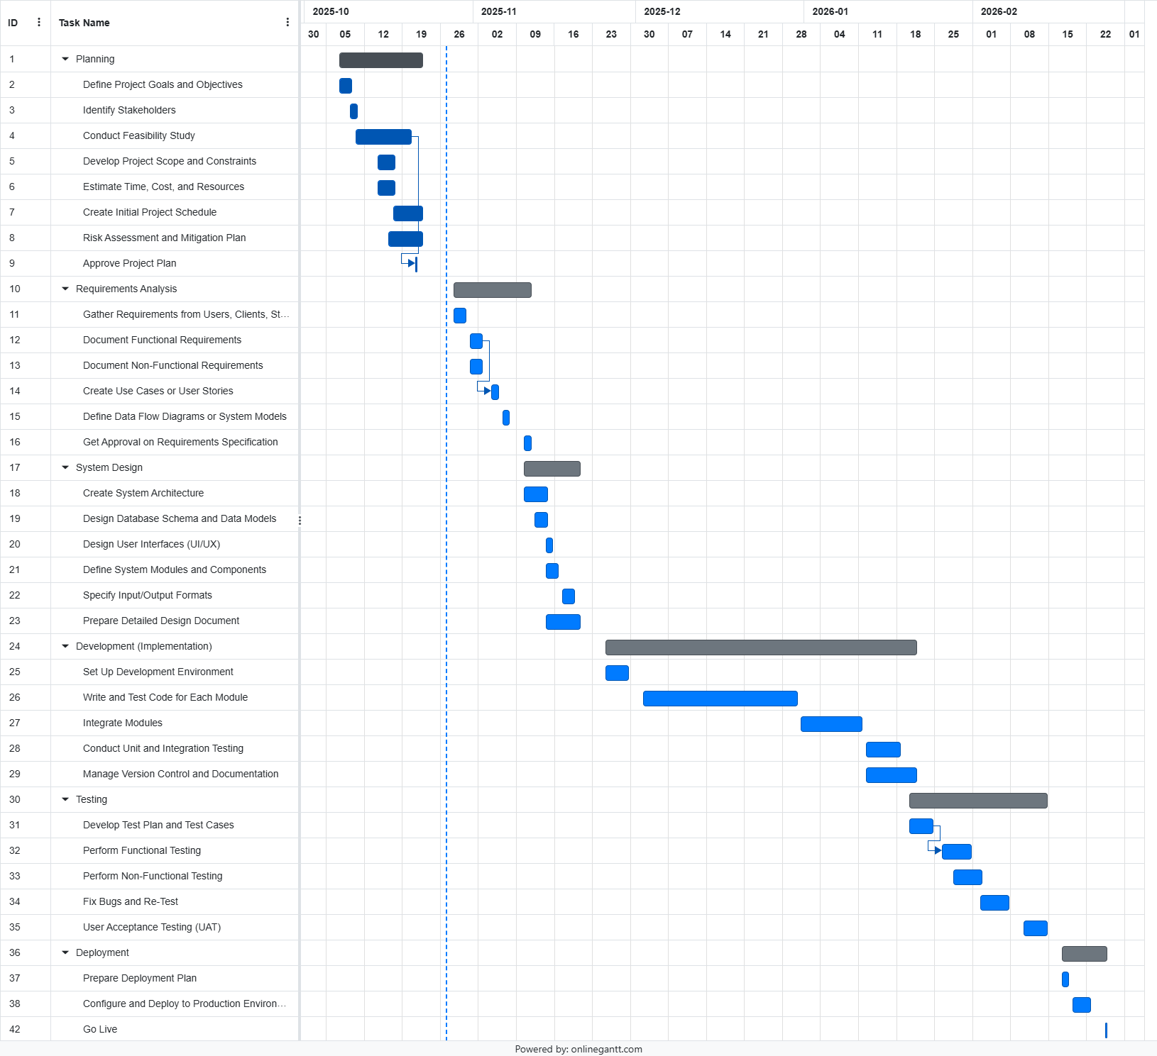

Project Management Tools to be Used
To ensure smooth collaboration and efficient time delivery, our team will adopt a hybrid Agile-Waterfall methodology. From a broader perspective, the waterfall framework will be applied. What this means is that the key milestones, such as feasibility reporting, system design, implementation, testing, and deployment, will follow a structured, step-by-step process. However, when we focus on individual modules, agile practices will be applied for iterative development and continuous development.
Notion will be used to manage sprint planning, assign tasks with time periods, create checklists, and track status using Kanban boards to monitor progress. GitHub will serve as our central version control system, allowing for collaborative coding, branching, and integration.
For report and documentation submissions, Microsoft Word will be used for team collaboration and feedback sharing. For weekly meetings, Webex will be used to discuss the progress as a group, including what has been completed, what is in progress, current challenges, and possible solutions. WhatsApp will be used for informal communication and quick daily updates.
By using this hybrid project management framework, the team can stay clear about everyone’s progress, making sure each member is performing their tasks efficiently, and keeping the project running smoothly throughout the six months.

Teamwork Distribution
The project responsibilities over the next two semesters are distributed in a way that ensures each member has an equal share of work. The team will maintain flexibility rather than strictly adhering to assigned roles, with members providing support to one another across different modules when needed.

Member 1 – Integration and Version Control Lead (Leen Naser)
This member is responsible for managing GitHub repositories, handling API integrations within the system, and overseeing version control and testing deployments. They ensure that all modules remain connected, up-to-date, and function cohesively throughout the development process.
Member 2 – Database Architect (Yara Saab)
Responsible for maintaining two core databases: the Historical Complaints Database (used for model training with company-provided data) and the Main Complaint Database (storing complaints processed by the chatbot and sentiment model). This member also oversees data security and manages database flow and accessibility.
Member 3 – Frontend Developer (Hana Ayad)
Focused on developing the user interface and presenting the system in a functional, appealing, and marketable way. They are responsible for designing five key screens: Welcome, Chatbot, Formal Complaint, Results, and Employee Escalation; and integrating Power BI for visualization within the dashboard.
Member 4 – Backend Developer (Rami Alassi)
Handles the backend logic and connectivity for all five major screens, ensuring seamless communication between the interface, databases, and APIs. Works closely with the frontend developer to maintain consistency, responsiveness, and proper data exchange.
Member 5 – AI Developer (Text) (Majid Sharaf)
Responsible for developing the text-based machine learning model, which performs sentiment analysis on complaint text data using insights from historical datasets. The model’s role is to analyze emotional tone and urgency, producing an output that determines complaint priority.
Member 6 – AI Developer (Audio) (Ali AlMaharif)
Focuses on the audio sentiment model and speech transcription component. This member develops the model that processes voice inputs and extracts emotional tone and urgency. They work closely with the text model developer to unify outputs and ensure both models align during integration.
Members 5 and 6 will coordinate closely with Member 1 to integrate the AI models into the system and ensure smooth functionality across modules.
Member 7 – Chatbot Engineer (Hamad Subhi)
Responsible for designing and implementing the chatbot, which serves as the initial point of interaction for users. This member ensures the chatbot functions effectively, communicates naturally, and integrates seamlessly with the backend and sentiment analysis model.
MLflow. (n.d.). MLflow - A platform for the machine learning lifecycle. [online] Available at: https://mlflow.org/.
‌ Apache Airflow. (n.d.). Home. [online] Available at: https://airflow.apache.org/.
‌

‌

References
Carpio-Talleux, A. (2025). Salesforce Service Cloud vs Zendesk: which customer service should you choose? [online] Appvizer. Available at: https://www.appvizer.com/magazine/customer/customer-service/salesforce-service-cloud-vs-zendesk [Accessed 11 Oct. 2025].
Kemp, C. (2021). IBM Watson Assistant model monitoring and improvements. [online] Medium. Available at: https://blog.chatbotslife.com/ibm-watson-assistant-model-monitoring-and-improvements-4e39c2d10560 [Accessed 11 Oct. 2025].
Panah, M. (2025). Best 24 help desk software and ticketing systems for 2025. [online] Zendesk. Available at: https://www.zendesk.com/service/help-desk-software/ticketing-system/ [Accessed 26 Oct. 2025].
‌James, R. (2025). 9 Best Call Center Speech Analytics Software (2025). [online] Amplifai.com. Available at: https://www.amplifai.com/blog/call-center-speech-analytics-software [Accessed 26 Oct. 2025].
RASA (2019). Rasa: Open source conversational AI. [online] Rasa.com. Available at: https://rasa.com/.
‌Amazon Web Services, Inc. (2019). Amazon RDS for PostgreSQL – Amazon Web Services (AWS). [online] Available at: https://aws.amazon.com/rds/postgresql/.
Apache Airflow. (n.d.). Home. [online] Available at: https://airflow.apache.org.
Tiangolo.com. (2025). FastAPI. [online] Available at: https://fastapi.tiangolo.com/ [Accessed 28 Oct. 2025].
‌Amazon Web Services, Inc. (n.d.). Managed Open-Source Elasticsearch and OpenSearch Search and Log Analytics – Amazon OpenSearch Service (successor to Amazon Elasticsearch Service) – Amazon Web Services. [online] Available at: https://aws.amazon.com/opensearch-service/.
AWS (2025). Cloud Object Storage | Store & Retrieve Data Anywhere | Amazon Simple Storage Service. [online] Amazon Web Services, Inc. Available at: https://aws.amazon.com/s3/.

AWS (2025). Cloud Object Storage | Store & Retrieve Data Anywhere | Amazon Simple Storage Service. [online] Amazon Web Services, Inc. Available at: https://aws.amazon.com/s3/.
‌pysentimiento (2025). GitHub - pysentimiento/pysentimiento: A Python multilingual toolkit for Sentiment Analysis and Social NLP tasks. [online] GitHub. Available at: https://github.com/pysentimiento/pysentimiento [Accessed 28 Oct. 2025].

